AWS - Resumo

Amazon Aurora

-You would like to ensure you have a database available in another region if a disaster happens to your main region. Which database do you recommend? -> Aurora Global Database.

- It is a proprietary technology from AWS (not open source)
- Postgres and MySQL are both supported as Aurora DB (your drivers will work as if Aurora was a Postgres or MySQL DB);
- Aurora is AWS cloud optimized and claims 5x performance improvament over MySQL on RDS. 3x over Postgres and RDS.
- Aurora storage automatically grows in incrments of 10GB up to 64TB
- Aurora can have 15 replicas while MySQL has 5, and the replication process is faster.
- Failover in Aurora is instanteneous.
- Costs more than RDS (20% more)- but it is more efficient.
- Automatic fail-over, backup and recovery, isolation and security, industry compliance, push-button scaling, advanced monitoring, routine maintenance.
Security: Encryption at rest using KMS. similar to RDS.Automated backups, snapshots and replicas are also encrypted. Encryption in flight using SSL, possibility to authenticate using IAM token. You are responsible for protecting the instance with security groups. You cant SSH.
Serverless: Automated database instantiation and auto-scaling based on actual usage. Good for infrequent intermittent or unpredictable workloads. No capacity planning needed. Pay per second, can be more cost-effective.
Global Aurora: Aurora cross region read replicas, useful for disaster recovery, simple to put in place. Aurora Global Database. One primary region (read / write), up to 5 secondary(read-only) regions, replication lag is less than 1 second. Up to 16 Read Replicas per secondary region. Helps for decreasing latency. Promoting another region for disaster recovery has an RTO of < 1 min.

AWS Api Gateway

- Serverless App (Lambda function and API Gateway) processing request with big spike resulting error 504. It means that API Gateway timed out because of lambda running more than 29 seconds.
- Lambda and API Gateway using proxy integration. Api caching enabled in API Gateway with TTL value of 300 secs. Client want to fetch latest data and invalidate cache. Send request with “cache-control: max-age=0” on header.

AWS EBS

- EBS volumes are AZ locked.
- EBS is a network drive you can attach to your instances while they run. It allow your instances to persist data. It is a network drive (not physical), It uses the network to communicate the instance, which means there might be a bit of latency. It can be detached from an EC2 instance and attached to another quickly.
- An EC2 machine loses its root volume (main drive) when it is manually terminated.
- Unexpected terminations might happen from time to time (AWS would email you).
- Sometimes you need a way to store your instance data somewhere.
- It is locked to an AZ. An EBS volume in us-east-1a cannot be attached to us-east-1b. To move a volume across, you first need to snapshot it.
-get Billed for provisioned capacity. You can increase capacity.
-> types:
- GP2: General purpose SSD volume that balances price and performance for a wide variety of workloads.
-IOI: HIghest performance SSD volume for mission-critical low-latency or high-throughput worloads.
-STI: Low cost HDD volume designed for frequently accessed, throughput intensive workloads.
-SCI: Lowest cost HDD volume designed for less frequently accesses workloads.

EBS vs Instance Store
- You would like to have a high-performance cache for your application that must not be shared. You don’t mind losing the cache upon termination of your instances. Use Instance Store.
- If you are running a high-performance database that requires an IOPS 210,000 for its underlyng silesystem. Use Instance store.
- Some instances do not come with Root EBS volumes. Instead come with instance store (physically attached to the machines);
PROS: better I/O performance, good for buffer / cache / temporary content, Data survive reboots.
CONS: on stop or termination, the instance store is lost, you cant resize the instance store, backups must be operated by the user.
-> Local EC2 instance store: Physical disk attached to the physical server where your EC2 is. Very high IOPS. Cannot be increased in size. Risk of data loss if hardware fails.

AWS EFS

- Managed NSF, works with multi-AZ.
- Highly available, scalable, expenseive, pay per use.
- use case: content management, web serving, data sharing, wordpress
- Uses NFSv4.1 protocol
- Uses security group to control access EFS
- Compatible with linux based AMI/
-encryption at rest KMS.

Performance & Storage Classes:
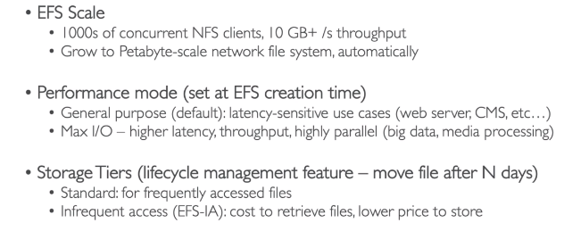
EFS vs EBS

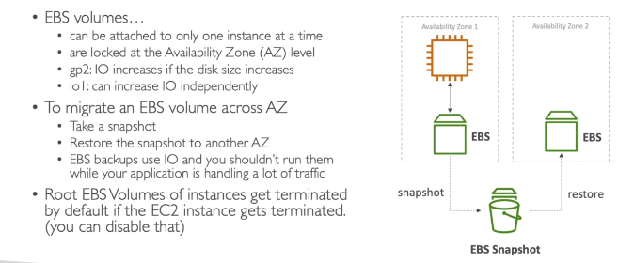

AWS ElasticCache

-Your application functions on an ASG behind an ALB. Users have to constantly log back in and you'd rather not enable stickiness on your ALB as you fear it will overload some servers. What should you do? -> Store session data in ElasticCache.
-One analytics application is currently performing its queries against your main production database. These queries slow down the database which impacts the main user experience. What should you do to improve the situation? -> Setup a Read Replica
-You have a requirement to use TDE (Transparent Data Encryption) on top of KMS. Which database technology does NOT support TDE on RDS? -> PostgresSQL
-Which RDS database technology does NOT support IAM authentication? -> Oracle (MySQL and Postgress support it)

- It is to get managed Redis or Memcached. Caches are in-memory databases with eally high performance, low latency. Helps reduce load off databases for read intensive workloads. Help make your app stateless. Write scaling using sharding. Read scaling using Read replicas. Multi AZ with Failover capability. AWS takes care of OS maintenance / patching, optimizations, setup, configuration, monitoring, failure recovery and backups.
- Applications queries ElasticCache if not available, get from RDS and store in ElasticCache. Helps relieve load in RDS. Cache must have an invalidation strategy to make sure only the most current data is used in there.
- Redis vs Memcached:
Redis -> Multi AZ with Auto-failover; Read replicas to scale reads and have high availability; Data durability using AOF persistence; Backup and restores features.
Memcached -> Multi-node for partitioning of data (sharding); Non persistent; No backup and restore; Multi-threaded architecture.
- Strategies:
1) Lazy Loading / Cache-Aside / Lazy Population: Pros -> Only requested data is cached (the cache isnt filled up with unused data); Node failures are not fatal (just increased latency to warm cache) Cons -> Cache miss penalty that results in 3 round trips, noticeable delay for that request. It is a easy to implement and works for many situations as a foundation, especially on the read side.
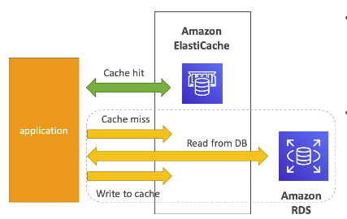

2) Write through - Add or update cache when database is updated. Pros -> Data in cache is never stale, read are quick. Write penalty vs Read penalty. Cons -> Missing data until it is added / updated in the DB. Mitigation is to implement Lazy loading strategy as well. Cache churn - a lot of the data will never be read. It is usually combined with Lazy loading as targeted for the queries or workloads that benefit from this optimization.
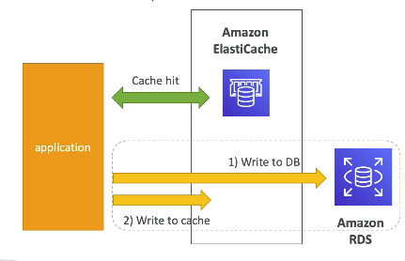

Cache Evictions and TTL. Cache Eviction can occur in three ways: You delete the item explicity in the cache; item is evicted because the memory is full and it is not recently used (LRU); You set an item TTL.
TTL are helpful for any kind of data: Leaderboards, comments, activity streams. TTL can range from few seconds to hours or days. Setting a TTL is usually not a bad idea except when you’re using Write-through. Set it to a sensible value for your application. Only cache the data that makes sense. (user profiles, blogs, etc)

AWS ELB

-Provide static DNS name we can use in our applications.

-You are running a website with a LB and 10 ec2. your users complain about the fact that your website always asks them to re-authenticate when they switch pages. You are puzzled, because it is working fine on your machine and in the dev env. The problem is related to Stickiness, it is not enabled.

-If you want to check the real IP address of the clients connected on a ALB -> loof into the x-forwarded-for header.

-You quickly created ELB and it turns out your users are complaining about the fact that sometimes the servers just down work. You servers crash from time to time. How to protect your users from mseeing these crashes? Enable Health Checks.

-The ALB target groups cannot be NLB, only ECS, lambda and IP adress.

-Application load balancer cannot redirect based on Client IP address, only hostnames and request path.

-You would like to expose a fixed static IP toi your end-users for commpliance purposes, so they can write firewall rules that will be stable and approved by regulators. Use NLB.

- Why use Load balancers? Spread load across multiple downstream instances, expose a single point to access (DNS) to your app, Seamlessly handle failures of downstream instances, Do regular health checks to your instances, Provide SSL termination (HTTPS) for your website, High availability across zones, Separe public traffic from private.
-ELB, aws guaratees that it will work, takes care of upgrades, maintenance, high avilability. It cost less to setup your own load balancer but it will be a lt more effort. Integrated with many AWS offerings;
-Classic Load Balancer (HTTP, HTTPS, TCP) support only SSL certificate Must use CLB for multiple hornames with multiples SSL.
-Application Load Balancer (HTTP, HTTPS, WebSocket) recommended, supports multiple listeners with multiple SSL certificates. Uses server name indication (SNI) to make it work.
-Network Load Balancer (TCP, TLS and UDP) Support multiple listeners with multiple SSL certificates. Uses server name indication (SNI) to make it work.
-4xx are client errors, 5xx are application, 503 means no registered target, check security group if app cannot connect do ELB.
-CloudWatch gives you statistcs and logs.

-Application Load Balancer: To multiple HTTP applications across machines and multiple applications on the same machine (ECS). Good for microservies and container-based apps. Ir can route to multiple target groups. Health Checks are at the target group level. Has fixed host-names (xxxx.region.elb.amazonaws.com) It does not see the IP of the client directly. The tru IP of the client is inserted in the header (X-forwarded-for) we can also get port and proto.

-Network Load Balancer: are used for extreme performance, TCP or UDP traffic and has ONE static IP per AZ.

-Load balancer STICKINESS: it is possible to implement stickiness so that the same client is always redirected to the same instance behind a load balancer. It work for classic and application LB. The cookie has an expiration date you control.

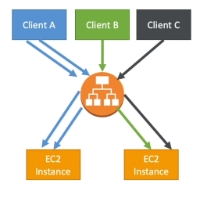

-Cross zone Load Balancing: Each load balancer instance distributes evenly across all registered instances in all AZ. For Classic Load Balancer it is disabled by default. No charges for inter AZ data. On Application LB, it is always on and cannot be disabled, and no charges are done. For Network LB, it is disabled by default and is charged in enabled.
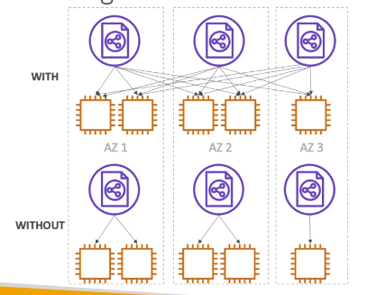

- SSL/TLS - Basics: SSL allows traffic between your clients and your load balance encrypted in transit. SSL refers to Secure Sockets layer, used to encrypt connections. TLS is Transport Layer Security which is a newer version.
-Load balancer uses an X.509 certificate and you can manage the certificates with AWS Certtificate Manager. You can create and upload your own certificates.

-SNI (Server Name Indication) - SNI solves the problem of loading multiple SSL certificates onto one web server (to server multiple websites). It is a newer protocol, and requires the client to indicate the hostname of the target server in the initial SSL handshake. The server will then find the correct certificate, of return the default one. Onlt ALB and NLB work with this.

-Connection Draining: CLB -> connection draining, or if you have a target grouo: Deregistration Delay. (ALB and NLB). It is time to complete “in-flight” requests while the instance is de-registered or unhealthy. Stops sending new requests to the isntance which is de-registered. Between 1 to 3600 seconds default is 300 seconds. Can be disabled. (value is set to 0). Set to a low value if your requests are short.

AWS ASG

- Scale out and scale in EC2 instances to match a decreased or increased load. Ensure we ave minimum and maximum number of machines. Automatically register new isntances to a load balancer.
-It has AMI + instance type, EX2 User data, EBS volumes, Security groups, SSH key pair. Min size/ max size / initial capacity. Network + subnets info. Load balancer info and scaling policies.
-It is possible to scale using CloudWatch alarms, alarms monitor metrics (average CPU, network i.e) Metrics are computed for the overall ASG instances. Based on the alarm we can create scale out and scale in policies
-We can auto scale based on a custome metric. (number of connections users). Send custom metric from application on EC2 to CloudWatch (PutMetric), create cloud watch alarm to react to low and high values
-IAM roles attached to ASG will be attached to EC2.
- it is freem you pay for the underlying resources being launched. Having instances under an ASG means that if they get terminated for whatever reason, the ASG will automatically create new ones as a replacement.
-Can terminar instances marked as unhealthy by LB.

-Scaling policies:

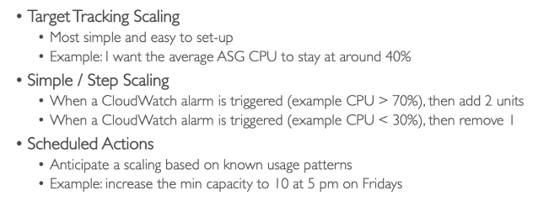

-Scaling cooldown
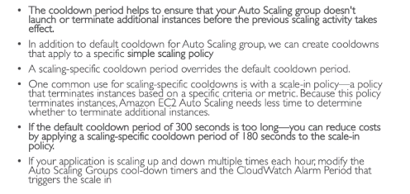
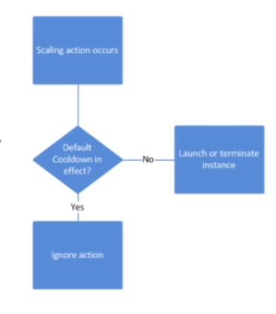

AWS CloudWatch

- App needs immediate insight monitoring. Collecting info of user every 10 seconds. High resolution custom metric in CloudWatch. Publish a high-resolution metric to CloudWatch. Standard resolution with data having a one-minute granularity. High resolution allows up to one second. PutMetricData call for a custom metric is charged, so calling it more often on high-reslolution can lead to higher charges.
-Api gateway and lambda function proxy integration takes a long time to complete its processing. You want to monitor the responsiviness of API. Some requests had time out. Which CloudWatch metrics should take to throubleshoot it? IntegrationLatency and Latency. You can monitor API execution using CloudWatch, which collects and processes raw data from API Gateway into readable, neal real-time metrics. These statistics are recorded in a period of 2 weeks. By default API GW metrics is sent automatically to CloudWatch in one-minute period. IntegrationLatency is responsible to show the responsiviness of the app. Latency shows overall responsiviness of your API calls. CacheHitCount and CacheMissCount metrics to optimize cache capacities to achieve a desired performance.

- You have a node JS lambda function that updates DynamoDB table and sends email notification via SNS. Lambda function is not working. How troubleshoot? Using X-ray (works for EC2, ECS, Lambda, ElasticBeanstalk), you can debug apps in prod/dev MS app. AWS CloudTrail only enables you to track all API calls to lambda functions, dynamo and SNS. AWS CloudWatch you can troubleshoot issue on logs but X-ray is better for debugging.
-Website hosted in AWS has a custom CloudWatch metric to track all HTTP server errors in the site per minute. An existing CloudWAtch alarm has already been configured for this metric but you would like to reconfigure this properly monitor app. The alarm should only be triggered when all three data points in the most recent three consecutive periods are above threshold. Which is the most appropriate way to monitor the website based on threshold? You must set the “EvaluationPeriod” and “Datapoints to Alarm” to 3. When you create an alarm, you specifiy three settings to enable cloudwatch to evaluate when to change the alarm status: Period is the length of time to evaluate the metric or expression to create each individual data point for an alarm, expressed in seconds; Evaluation Period and Datapoints to alarm.

- Lambda function base app of several functions is set. Once triggered, various downstream resources like DynamoDB and S3 or API calls will be made. Requirement to trace event source that invoke all lambda functions and trace downstream, number of requests, and execution duration per request. CloudWatch can be used to emit metrics and logs for all invocation of your functions. It’ll be done automatically by CloudWAtch.

- Lambda function which will send updates to a third party provider for analytics. Need to schedule the function to run every 30 minutes. Which of the following is the most manageable and cost-effective way to setting up this task? Integrate CloudWatch events with landa which will aumatically trigger the lambda function every 30 minutes. CloudWatch events help you to respond to state changes in your AWS resources. When your resources change state, they automatically send events into an event stream. You can create rules that match selected events in the stream and route them to your AWS Lambda fnction to take action.

-It provides metric for every services in AWS. Metric is varialbe to monitor (CPU Utilization, Network). Metrics belongs to namespace. Dimension is an attribute of a metric (instance id, environment, etc...). Up to ten dimensions per metric. Metric have timestamp. Can create CloudWatch dashboard. EC2 instance metrics have metric every 5 minutes. With detailed monitoring, you get every 1 minute. Use detailed monitoring if you want to more prompt scale your ASG. The AWS free tier allows us to have 10 detailed monitoring metrics. Custom metrics. Ability to use dimensions (attributes) to segment metrics. Instance id, environemtn name. Metric standard resolution is 1 minute. High resolution up to 1 sec. (to enable: StorageResolution API). higher cost. Ude API call PutMetricData. Use exponential back off in case of throttle errors.

-CloudWatch alarms. Are used to trigger notifications for any metric. Can go to ASG, EC2 and SNS. Alarm states: OK , INSUFFICIENT_DATA, ALARM. Apllications can send logs to CloudWatch using SDK. CloudWatch can collect log from Elastic BeanStalk, ECS, AWS, VPX, API Gateway, CloudTrail, Route53. Can go to Batch exporter to S3. Stream to ElasticSearch cluster.

-CloudWatch logs can use filter expressions. Logs storage architecture: Log groups (arbitrary name, usually representing an application; Log stream: insttances within application
- Can define log expiration policies (never expire, 30 days, etc..)
- Security, using KMS to encrypt logs a the Group lever.

-CloudWatch events: Schedule using Cron jobs. Event pattern: Event rules to react to a service doing something (ex: codepipeline state changes). Triggers to lambda functions, SQS/SNS/Kinesis Messages. CloudWatch event creates small JSON document to give info about the changes.

- Lambda base app of several functions. Once triggered, various down streams resources like dynamoDB and S3 or API calls will be made. Requirement to trace event source that invoke all lambda functions and trace downsteam, number of requests and execution requests. CloudWatch used to automatically emit metrics and logs for all invocation of your lambda functions.

AWS CodeCommit

- Use Least Privilege permissions to a user managing all the code Repos and remove duplicated or unused. {“codecommit”: “CreateRepository”, “codecommit”: “DeleteRepository”}
- App hosted on CodeCommit which has a single Maste branch. Developer requires permission in order to pull and push code using git fetch, clone and push. To improve security, the developer should be granted only the permissions required. The permissions are: {“codecommit”: “GitPull”, “codecommit”: “GitPush”}. GitPull already is Fetch and clone.
- It is a private git repo.
- No size limit on repos.
- Fully managed, highly available.
- Code only in AWS Cloud account => increased security.
- Secure (encrypted, access control).
- Integrated with Jenkins, CodeBuild and other CI.
- Security: Interactions using Git, authentication using SSH keys, HTTPS, MFA. Authorization in Git use IAM Policies manage user / roles rights to repos.
- Encryption: repos automatically encrypted at rest using KMS. Encrypted in transit (HTTPS or SSH)
- Cross Account Access: Do not share SSH keys, AWS credentials, user IAM role in your AWS account and use AWS STS.
- Trigger notifications in CodeCommit using AW SNS or AWS Lambda or AWS CloudWatch Event Rules. Ex: deletion of branches, Notify external Build System, Trigger for pull request updates, etc..

AWS CLI

-AWS CLI shell script to list all objects on S3. Avoid timing out -> add PAGINATION (--page-size)

- private S3 bucket stored application logs and the buckets contents are accessible to all members of developer IAM group.However, I want to make an object inside the bucket which should only be accessible to the members of admin IAM group. How to apply an S3 bucket policy to thus object using AWS CLI? There is no way to do it. On AWS CLI you can only apply bucket level policy, not on objects. Use S3 access control lists instead to manage permissions of S3 objects. “put-bucket-policy” --policy is for bucket level.

- app sending thousand of log files to an S3 bucket everyday. Command request to retrieve list of objects using AWS CLI “aws s3 api list-objects” is timing out due to the high volume of data being fetched. User PAGINATION to solve this problem. Parameters to include: “--page-size” and “--maaz-items”

- app hosted on EC2 with assigned IAM Role to store data from both the development and prod S3 bucket. THe instance also has an AWS CLI installed to handler other ad hoc tasks. You assigned a new IAM role to the instance which has the permission to access the development bucket only. However, upon testing, the instance can still store files to the buckets. The cause is that the application is still using IAM Role that is configured in the AWS CLI.

-App on Elastic Beanstalk, handle deployment of new version of the app, Correct way to deploy new version to Elastic Beanstalk via CLI? Package your app as a zip file and deploy it using the eb-deploy command.

AWS CloudFront

- S3 behind CloudFront storing static content. Only premium are authorized to access. Unauthorized access should be denied. User Lambda@Edge and Cognito to authenticate and authorize premium customer.

AWS Cognito

- I want to create an authentication using social identity provider to upload files on S3. Enable guest user access to certain sections of website. TO do this you have to create an Identity Pool in Cognito and enable access to unauthorized identities.
- S3 behind CloudFront storing static content. Only premium are authorized to access. Unauthorized access should be denied. User Lambda@Edge and Cognito to authenticate and authorize premium customer.

AWS Dynamo DB
- multi container docker on Elastic Beanstalk uses Dynamo DB to handle session data of its users. These data are only used in a particular time frame and the stale data can be deleted after the user logged out of the system. Enable TTL for the session data in the Dynamo DB table.

AWS EC2

- app hosted on EC2 with assigned IAM Role to store data from both the development and prod S3 bucket. THe instance also has an AWS CLI installed to handler other ad hoc tasks. You assigned a new IAM role to the instance which has the permission to access the development bucket only. However, upon testing, the instance can still store files to the buckets. The cause is that the application is still using IAM Role that is configured in the AWS CLI.

-bootstrap can be used, launching commands when machine starts. Command run only once.

-Use User Data to provide startup instructions to EC2.

-On demand: short workload, predictable pricing.
- Reserved: Minimum one year. Long workloads, up to 75% discount compared to on-demand. Pay upfront from what you use with longe term, reservation from 1 to 3 years. Reserve a specific instance type. Convertible can change EX2 instances and Scheduled launch within time window you reserve.
-Spot instances: short workload, for cheap, can lose instances
-Dedicated instances: No other customers will share your hardware.
-Dedicated Hosts: book an entire physical server, control instance placement.

-Elastic Network Interfaces: They are logical component in VPC that represents a virtual network card. EC2 has it attached and provides ec2 instance network connectivity. It has a primary private IPv4 or more, you can add multipĺe ENI on a EC2 and will offer more IPv4. Elastic and public IPv4. You can have one or more security groups attached on it. You can create it independently and attach them on the fly on EC2 instances for failover.

- Pricing: Prices are per hour depending on region, instnace type and on-demand, spot, dedicated host. You are billed by the second, with a mnimum of 60 seconds. You pay for other factor such as storage, data transfer, fixed IP, public address, load balancing but you do not pay when it is stopped. If you use 6 seconds, billed for 60 seconds,

-AMI can be used to create customized EC2 isntances. if you need pre-installed packages, faster boot time, etc.. AMI are build for a specific AWS regioin.

-Instances have RAM, CPU, I/O, Network and Graphical Processing as difference.

-T2 are busrtable instances. Overal the instance has OK CPU performance. When the machine needs to process something unexpected, it can burst and CPU can be very good. it uses burst credits. if credits are gone, becomes really BAD.

- You plan to use a running open-source mongoDB database year-round. Use Reserved Instnaces to save money, as you know advanced that it will be a up for a full year.

-AMI are locked to a specific region, and the same ID cannot be used across regions. If you upload on us-east-1 it’ll fail to up on a different region.

-Dedicated hosts allow you to get visibility into physical cores and underlying network socket visibility.

- You are runing a critical workload oof three hours per week. Which EC2 instance Launch type should you choose to maximize the cost saving while ensuring he app stability? Scheduled Reserved Instances.

AWS Elastic Cache

-You are implementing a caching strategy with ElastiCache and would like to ensure that only the data that is often requested will be loaded in ElastiCache, as your cache size is small. Which caching strategy should you implement? -> Lazy loading. Lazy loading would only cache data that is actively requested from the db.

-You are serving web pages for a very dynamic website and you have a requirement to keep latency to a minimum for every single user when they do a read request. Writes can take longer to happen. Which caching strategy do you recommend? -> write-through

- Refactoring legacy app storing user session state in memory with performance and high availability. Use Elastic Cache for redis cluster to store user session.

-Web app with multi-thread event based (k/v) cache store. (Caching DB results). run large nodes with multiple cores for cache to scale up/down. Use Elastic Cache for memcached.

-Web app using Elastic Cache cluster that is suffering from cache churn, which means that a lot of cache data in cluster are never read. There is a requirement to reconfigure the app to retrieve the data from the DB only in the event that there is a cache miss. Implement lazy loading. Lazy Loading would only cache data that is actively requested from the database

-Redis: multi AZ with Auto-Failover, read replicas to scale reads and have high availability, Data durability using AOF persistence, backup and restore features
-Memcached: multi-node for partitioning data (sharding), non persistent, no backup and restore, multi-thread.

-Our RDS database struggles to keep up with the demand of the users from our website. Our million users mostly read news, and we don't post news very often. Which solution will NOT help fix this problem? RDS Multi AZ.

-It is to get managed Relational Databases, redis or memcached. Caches are in-memory databases with really high performance, low latency.

AWS EC2

- app hosted on EC2 with assigned IAM Role to store data from both the development and prod S3 bucket. THe instance also has an AWS CLI installed to handler other ad hoc tasks. You assigned a new IAM role to the instance which has the permission to access the development bucket only. However, upon testing, the instance can still store files to the buckets. The cause is that the application is still using IAM Role that is configured in the AWS CLI.

- Renting virtual machines, Storing data on virtual drives (EBS), Distributing loads across machines (ELB), Scaling the servies using an auto-scaling group (ASG)

-SSH troubleshooting: connection timeout is group issue (security).

AWS Elastic Beanstalk

- Most of the web apps have the same architecture (ALB +ASG). Elastic Beanstalk is for avoid managing infrastructure, scaling concerns, etc... Instance config, OS is handled by Beanstalk. Deployment strategy is configurable but performed by Elastic Beanstalk. Three architecture models: Single instance dployment, LB +ASG, ASG only. EB has three components: Application, version (each dployment get assigned to a version), environment variables (dev, test, prod), free naming. You deploy app versions to enviroments and can promote application versions to the next environment. Rollback feature to previous application version. Full control over lifecycle of environemnts.

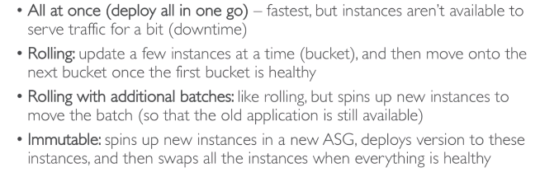

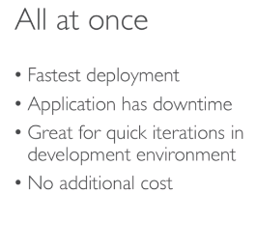
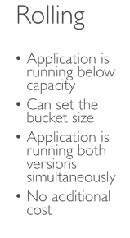
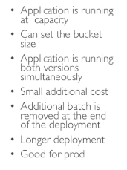
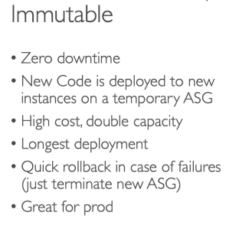

- Developer instructed to configure worker daemon to queue messages based on a specific schedule using work environment hosted in Elastic Beanstalk. Periodic tasks should be defined tu automatically add jobs to your worker envronment’s queue at a regual interval. Use “cron.yaml” in the source bundle to meet it.

- multi container docker on Elastic Beanstalk uses Dynamo DB to handle session data of its users. These data are only used in a particular time frame and the stale data can be deleted after the user logged out of the system. Enable TTL for the session data in the Dynamo DB table.

- Elastic Beanstalk to manage a web app. Configure its environment deployment policy to launch new EC2 instances, and then deploy the new version of your app only to these new resources. How to meet this requirement with a deployment method? methods:
1-) All at once: deploy new version to all instances simutaneously all instances will be out of service for a short time.
2-) Rolling: deploy in batches. Each batch is taken out of service during the deployment phase, reducing environment’s capacity by the number of instances in a batch.
3-) Immutable: Deploy the new version to a fresh group of instances by performing an immutable update
4-) Blue/Green: Deploy the new version to a separate environment, and then swap CNAMEs od the two environments to redirect traffic to the new version instantly.

-Application performs various workflows and process long-running tasks that take a long time to complete. App is unresponsive since the workflow increased the time it takes to complete a user request. How to improve performance? Use elastic beanstalk worker environment to process the tasks async.

to find it:

= reservoir size + ( (incoming requests per second - reservoir size) * fixed rate)
= 150 + ((200 - 100) * 20%) = 160 requests

- App hosted on Elastic Beanstalk running Java 7. A new version of the app is ready to be deployed and a dev was tasked to upgrade the platform to Java 8. Which of the following is the most appropriate action to upgrade the platform. Perform Blue / Green deploy. Elastic Beanstalk has two methods for performing platform updates.
1-) Update your Environment’s Platform Version. This is recommended when you’re updating to the latest platform version, without a change in runtime, web server, or application server versions, and without in the major platform version
2-) Platform a Blue/Green deployment - This is the recommended method when you’re updating to a different runtime, web server, or app server versions, or to a different major platform version.

-App on dev account running on ElasticBeanstalk. With RDS database attached. If you terminate the environment, it also brings down the database which hinders you from performing seamless update with blue-green depoyments. How to decouple your DB from your environment without any data loss? Use Blue/Green deploy strategy to decouple Amazon RDS from Elastic Beanstalk environment. Create an RDS DB snapshot of the DB and enable deletion protection. Create a new Elastic Beanstalk environemnt with the necessary info to connect to RDS. Before terminanting the old Elastic Beanstalk, remove its security group rule before proceeding.

-App migrated from data center to Elastic Beanstalk. Required to deploy the application’s new version to all instances simultaneously in order for their clients to view the changes imediately. Which of the following options take the least amount of time to complete the deplloyment? All at Once.

-App on Elastic Beanstalk, handle deployment of new version of the app, Correct way to deploy new version to Elastic Beanstalk via CLI? Package your app as a zip file and deploy it using the eb-deploy command.

-With HTTPS: Idea: Load the SSL certificate onto the Load Balancer. Can be done from the console. Can be done from the code (.ebextensions/securelisterner-alb.config). SSL certificate can be provisioned using ACM (AWS Certificate Manager) or CLI. Must configure a security group rule to allow incoming port 443. If your applcication performs tasks that are long to complete, offload these tasks to a dedicated worker environment. Decoupling your application into two tiers in common. You can define periodic tasks in a file “cron.yaml”.

- Elastic Beanstalk Migration Load balancer. After creating an Elastic Beanstalk environment, you cannot change the Elastic Load Balancer type (only config). To migrate: Create a new environment with the same configuration except LB (cant clone); Deploy your application onto the new enviroment; perform CNAME swap or Route 53 update.

-With docker. provide a Dockerfile, EB will build and run the docker container; Dockerrun.aws.json (v1) Describe where already built Docker image is. Beanstalk in single docker container does not use ECS. Multidocker helps run multiple containers per EC2 instance in EB. This will create for you, ECS Cluster, EC2 instance, configured to use the ECS Cluster, Load Balancer, Task definition and execution. Requires a config Dockerrun.aws.json (v2) at the root of source code. Docekrrun.aws.jsonn is used to generate the ECS task definition. You docker images must be pre-built and stored in ECR for example.

- EB cloning. Clone an enviroment with the exact same config. Useful for deploying a “test” version of your app. All resources and configuration are preserved. LB type and configuration, RDS DB (data not preserved), Env vars. After cloning an env, you can change settings.

AWS Encryption

- Ensure that all objects in S3 bucket are encrypted at rest using server-side encryption with AWS KMS-Managed Keys (SSE-KMS). Add a bucket policy which denies any s3:PutObject action unless the request includes the “x-amz-server-side-encryption” header.
-Encrypted all object uploaded in S3. Server side encryption SSE-S3 with AES-256. Use “x-amz-server-side-encryption” for not deny request.

AWS IAM

- It is global.

-Roles, User, Policies, Groups;

-IAM user can belong to multiple groups.

- If you get a permission error exception when trying to SSH into your Linux instance. The key is missing permission chmod 0400.

- Create multiple IAM users and groups, and assign policies to groups. New users will be added to groups.

- Each region has many zones. region ap-southeast-2 (2a, 2b ,2c). Each region are separated from each other. Policies are written in JSON. Roles are from AWS resources, User from physical person and Groups can be created (admin, devops). One IAM User per Physical Person, One IAM Role per Application.

- private S3 bucket stored application logs and the buckets contents are accessible to all members of developer IAM group.However, I want to make an object inside the bucket which should only be accessible to the members of admin IAM group. How to apply an S3 bucket policy to thus object using AWS CLI? There is no way to do it. On AWS CLI you can only apply bucket level policy, not on objects. Use S3 access control lists instead to manage permissions of S3 objects. “put-bucket-policy” --policy is for bucket level.

-app allows the user to easily make cartoon animation and store the generated media files to AWS. IAM role created with permissions to upload file to S3 and other AWS resources. Which API call should you use to allow the app to upload files to S3? AssumeRole. To assume a Role, an ap calls the AWS STS AssumeRole API operation and passes the ARN of the role to user. The operations create a new session with temporary credentials.

- app hosted on EC2 with assigned IAM Role to store data from both the development and prod S3 bucket. THe instance also has an AWS CLI installed to handler other ad hoc tasks. You assigned a new IAM role to the instance which has the permission to access the development bucket only. However, upon testing, the instance can still store files to the buckets. The cause is that the application is still using IAM Role that is configured in the AWS CLI.

AWS Kinesis

- App processing kinesis streamm with 4 shards and wants to scale to 6 shards. Max EC2 instances is 6.

- Set of EC2 instances which runs kinesis to process data stream. Streams are maxing out CPU utilization and there are insufficient Kinesis shards to handle the rate. Which is the best course of action to solve this issue? Increase both instance size and number of open shards.

- Kinesis data stream which has 20 open shards and 5 EC2 instances running as kinesis client library. Monitory CloudWatch shows EC2 worker are consuming all CPI resources. Best solution to optimize your app is launching 15 additional instances.

- It is a managed alternative to Apache Kafka. Streams are devided into ordered shards. Data retention is one day by default. can go up to 7 days. Ability to process and replay data. Multiple applications can consume from the same stream. Real-time processing with scale of throughput. Once data is inserted in Kinesis, it cant be deleted. Records ordered per shard.

-putRecord is a way to send data to kinesis. PutRecord API + Partition key that gets hashed.

-you are sending a clickstream for your users navigating your website, all the way to kinesis. t seems that the users data is not ordered in Kinesis, and the data for one individual user is spread across many shards. How to fix that problem? You should use a partition key that represents the identity of the user.

-You intermittently get a ProvisionedThroughtputExceeded Exception in yur app, you should use exponential backoff on retries.

-If you want a real time analytics on streams of data. The most appropriate product will be Kinesis.

-we’d like for our big data to be loaded near real time to S3 or Redshift. We’d like to convert the data along the way. Use Kinesis stream and firehose.

-Real-time traffic moniotoring system which users kinesis data stream to collect data and a group of EC2 instants that consume and process data stream. Adjust number of shards in the data stream to adapt to changes in the rate of data flow. You can increase the streams capacity splitting shards and you can decrease the strams capacity by merging shards.

AWS Lambda

- Serverless App (Lambda function and API Gateway) processing request with big spike resulting error 504. It means that API Gateway timed out because of lambda running more than 29 seconds.
- Lambda and API Gateway using proxy integration. Api caching enabled in API Gateway with TTL value of 300 secs. Client want to fetch latest data and invalidate cache. Send request with “cache-control: max-age=0” on header.

- Several Lambda function which reads data from RDS. Share same connection string that should be encrypted. How to protect? Create secure string Parameter using AWS System Manager Parameter Store.

- There’s a photo sharing app. How to prevent the app to be responsive effectively? Change lambda function to Event invocation type.

- Lambda function should process the data and store the results to a DB hosted in your VPC. The Lambda function cannot connect to the internet anymore. To solve it, ensure that the associated security group of the lambda function allows outbound connections and add a NAT to your VPC. If your lambda function requires internet access, you can configure a NAT instance inside your VPC or you can use the Amazon VPC NAT Gateway.

- Update lambda function on prod environment and ensure that when you publish the updated version, you still have a quick way to roll back to the older version. To prevent any sudden user interruptions, you want to gradually increase the traffic going to the new version. Use Traffic Shifting with Lambda Aliases. An alias points to a single lambda function. When the alias is updated to point to a different function version, incoming request traffic in turn instantly points to the updated version. This exposes that alias to any potential instabilities introduced by the new version. To minimize this impact, you can implement the routing-config parameter of the lambda alias that allows you to point to two different versions of the lambda and dictate what percentage of incoming traffic is sent to each version.

- Lambda function downloads a file with a size of 55MB from an external repo every time it is invoked. This causes the function to time out intermittently. How should you refactor the function? Store the file in the /tmp directory of the execution context and reuse it on succeeding invocations.

- Lambda function sending data to AuroraDB in VPC. Getting MySQL error 1040. Too many connections when there is a surge in incoming traffic. Lambda function is always creating a DB connection whenever it is invoked. How to overcome? Use the executor context and add logic in your code to check if a connection exists before creating one.

- Lambda function has an event source mapping to process requests from API gateway. The function will consistently have 10 requests/ second and it has maximum 50 secs to complete each request. How to prevent the function to throttling? Do nothing, since lambda function will automatically scale to handle the load. You can use a formula to estimate the capacity of function:
concurrent executions = (invocation per second) * (average execution duration in seconds)
30 = 10 * 3
If a lambda function takes 3 seconds and S3 publishes 10 events per second. The lambda function processes Amazon S3 events. The you’ll have 30 concurrent executions of your lambda function.
In the scenario cited above it’ll have 500 concurrent executions.

-Lambda function which will run in various events such as DEV, TEST and PROD. As part of its processing the function also calls a set of external API services which varies based on the environment. The function must use different endpoints for these external services to properly complete the processing. Which of the features in Lambda should developer use to reference the appropriate external endpoint for each env? Environment Variables. It enables you to dynamically pass settings to your function code and libraries, without making changes to your code. They are key-value pairs that you create and modify as part as your function config.

-Lambda function that process events notifications from S3. 50 requests / sec, 100 seconds to complete each request. What should you do to prevent any issues when the function has been deployed? Request for AWS to increase the limit of your concurrent executions. It will have 5000 concurrent executions. The limit is 1000 by default. Than you should ask for AWS to increase the limit.

-Deploying package of lambda function, compressed as ZIP. getting an error in the deployment because package is too large. Keep package small to make deployment? Upload the other dependencies of your function as separate lambda layer instead. Layers let you keep your deployment package small which makes development easier.

-AWS account using 2 lambda functions to process data and storing at S3. An ALB is used to distribute incoming traffic to the functions. In peak, the first lambda func works with optimal performance but the second on is throttling incoming request. Root cause? Concurrency execution limit provided to the first function is higher than second.

-Easiest way to deploy a lambda function? Include your lambda function source inline in the zip file paramter of the “AWS::Lambda::Function” resource in the CloudFormation Template.

- Serverless App composed of several Lambda functions and DynamoDB. Process requests async. Use “Invoke” API to call lambda functions and set the invocation type request parameter to “Event”. Lambda function can be executed sync and async. The invocation type can be controlled only when you invoke the function by yoour custom app or manually using AWS CLI. In the “Invoke” API you have 3 options to choose from the InvocationType. RequestResponse(default), Event and DryRun.

- Serverless app composed of lambda function and DynamoDB which process S3 events. A lambda function takes an average of three seconds to process the data and S3 publishes 10 events per second. How many concurrent executions will your func have? 30!!! (10 * 3)

-You have to control execution performance and costs of your lambda functions. There’s a requirement to increase the CPU available to your function in order to efficiently process records from an Amazon Kinesis. To solve it you have to increase the allocated memory of the function. The price depends on the amount of memory you allocate to your function. In AWS lambda resource model you choose the amount of memory you want for your function, and are allocated proportional CPU power and other resources.

- recently deployed app to a newly created AWS account which uses 2 identical lambda functions to process ad-hoc requests. The first process OK, second has no longer process time. Even though both functions have exactly same code. Based on monitoring, throttles metric of the second function is greater than first one in CloudWatch. To solve: set concurrency execution limit of both function to 450 OR decrease concurrency execution limit of the first function.

-IAM role must be attached to the function. Allocated memory (120MB to 3GB). Timeout: default 2 secs, max of 15 minutes.

-AWS lambda monitoring, logging and tracing. CloudWatch stores execution logs from lambda and metrics as well. Make sure Lambda has an execution role with an IAM policy that authorizes writes to CloudWatch. X-ray can be used to trace lambda and we have to enable it in lambda. Use AWS SDK in code. Ensure has IAM role.

-Limits to know: memory allocation is from 128MB to 3GB (64MB increment)
- Maximum execution times is 300 seconds (5 minutes)
- Disk capacity in the function container is 512MB
- Concurrency limits is 1000.
- Deployment size is 50MB
- Size of uncompressed deployment (code +dependencies) is 250MB
- Can use the /tmp directory to load other files at startup
- Size of environment variables is 4KB.

- AWS Lambda aliases are pointers to lambda function versions. WE can define many aliases and have them point at different lambda versions. Aliases enable Blue/ Green deployment by assigning weights to lambda functions. It enables stable configuration of our event triggers / destinations. Aliases have their own ARN.

- If your lambda function depends on external libraries (AWS X-Ray, SDK, Database Clients), you need to install the packages alongside your code and zip it together. Upload the zip straight to lambda if less than 50MB, else to S3 first.

- If lambda needs to download a big file to work, you can use the /tmp directory. Max size is 512MB. For permanent persistence of object, use S3.

- Good practice: Perform heavy-duty work outside of your function handler. Connect to database outside of your function, initialize AWS SDK outside of function. Use environment variables for database connection Strings, S3 bucket, Passwords, and sensitive values can be encrypted using KMS. Dont put function inside VPC unless you need it.

-Lambda Edge, want to run a global AWS lambda alongside, or implementing request filtering before reaching your application.

-AWS lambda does not support Docker.

-Your lambda function is invoked asynchronously and some events fail from being processed after 3 retries. You’d like to collect and analyze these events. What should you do? Use SQS adding dead letter to send message.

- You have enabled a lambda DLQ to SNS but you dont see any events there even though you can tell fromm Cloudwatch metrics that you have failues, your IAM execution role for lambda is missing permissions.

- You get the follwing exception: An error occurred (InvalidParameterValueException) when calling the UpdateFunctionCode operation: Unzipped size must be smaller than 262144000 bytes. It means the uncompressed zip file exceeds AWS lambda limits.

-you’d like to have a long string 8KB loaded in your lambda code. Place it in the code zip file.
-Every time you release a lambda function version, it gets a new number and you have to manually update all the AWS components linked to your functions. What should you use? Use function aliases and update the alias pointer.

- You want to test out a new Lambda function version and ensure it can sustain production traffic. You’re risk averse and dont want to take down your whole app. Use aliases and point to the new and old versions.

-You have an RDS instance and realize that every-time your AWS lambda function is called, it re-establishes a connection to your DB. You tell your developers to use a long live database connection string. they tell you to move the database connection object outside of the function handler.

AWS Lambda@Edge

- S3 behind CloudFront storing static content. Only premium are authorized to access. Unauthorized access should be denied. User Lambda@Edge and Cognito to authenticate and authorize premium customer.

AWS RDS

- You are managing a PostgreSQL database and for security reasons, you would like to ensure users are authenticated using short-lived credentials. What do you suggest doing? -> Use postgres SQL for RDS and authenticate using a token obtained through the RDS service.
- My company would like to have a MySQL database intrnally that is going to be available even in case of a disaster in the AWS cloud -> Multi AZ.
-Our RDS database struggles to keep up with the demand of the users from our website. Our million users mostly read news, and we don't post news very often. Which solution will NOT help fix this problem? -> Multi AZ (ElasticCache and RDS Read replicas are ok)
-We have setup read replicas on our RDS database, but our users are complaining that upon updating their social media posts, they do not see the update right away -> Read replicas have async replication and therefore it’s likely our users will only observe eventual consistency.
Which RDS Classic (not Aurora) feature does not require us to change our SQL connection string? ->
-Multi AZ keeps the same connection string regardless of which database is up. Read Replicas imply we need to reference them individually in our application as each read replica will have its own DNS name
- You want to ensure your Redis cluster will always be available -> Enable Multi AZ
- Your organisation wants to enforce SSL connections on your MySQL database -> Apply a “REQUIRE SSL” statement to all your users in your SQL database.

- Relational Database Service. It allows you to create a database in the cloud that are managed by AWS (postgres, MySQL, oracle, Microsoft SQL Server).
- It is a managed service. Automated provisioning OS patching. Continuous backups and restore to specific timestamp (Point in time restore).
-Monitoring dashboards. Read replicas for improved read performance.
- Cannot SSH into instances.
- Backups are automatically enabled in RDS. Automated backups. Daily full backup of the database. Transactions logs are becked-up by RDS. 7 days retentions.
-DB snapshot, manually triggered by the user. Retention of backup for as long as you want.

Read Replicas for read scalability: Up to 5 read replicas. Within AZ, cross AZ or Cross Region. Replication is ASYNC, so reads are eventually consistent. Application must update the connection string to leverage read replicas.
Read replicas: You have a production database that is taking on normal load. You want to run a reporting application to run some analytics. You create a Read replica to run the new workload there. The productioon application is unaffected. Read replicas are used for SELECT.
Network Cost: in AWS there’s a network cost when data goes from one AZ to another. To reduce cost, you can have your Read Replicas in the same AZ.
Disaster Recovery: SYNC replication. Failover in case of loss of AZ, loss of network, instance or storage failure. One DNS name. Increase availability. Not used for scanling.
Encryption: at rest encryption, Possibility to encrypt the master & read replicas with AWS KMS - AES-256 encryption. Encryption has to be defined at launch time.If the master is not encrypted, the red replicas cannot be encrypted. Transparent Data Encryption (TDE) available for Oracle and SQL server.
In-flight encryption: SSL certificates to encrypt data to RDS in flight. Provide SSL options with truste certificate when connectin to database. To enforce SSL:
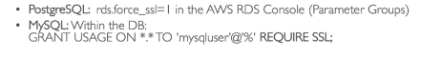

Encrypting operations:
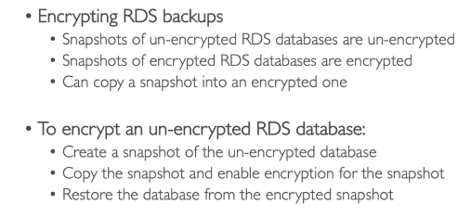

After thatjust migrate applications to the new database, and delete the old one.

Network & IAM:
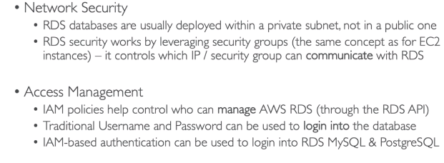
IAM Authentication:
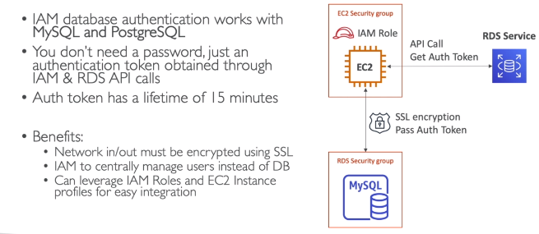

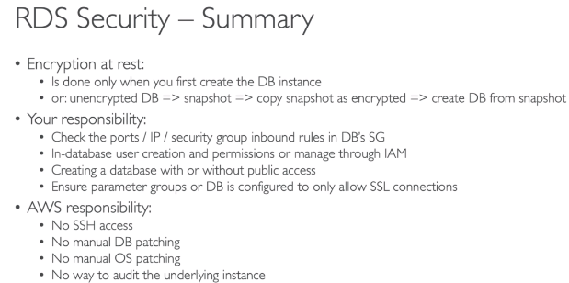

AWS Route 53:

- It is a managed DNS. DNS is a collection of rules and records which helps clients understand how to reach a server through its domain name.
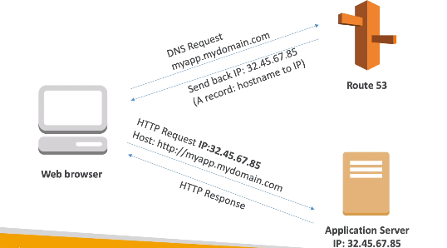

Can use: public domain names you own. It has advanced feature such as load balancing, health checks, routing policy, simple, failover, geolocation.

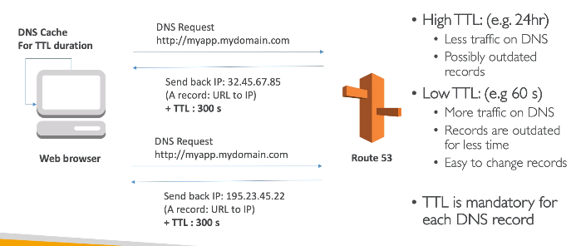

- AWS Resources (Load balancer, CloudFront...) expose an AWS hostname(1b1-1234.us-east-2.elb.amazon) but you want myapp.mydomain.com.
-> CNAME: Points a hotname to any other hostname (app.mydomain.com -> blabla.anything.com) ONLY FOR NON ROOT DOMAIN.
->Alias: Points a hostname to an AWS resource (appdomain.com -> blabla.amazonaws.com) Works for ROOT DOMAIN and NON ROOT DOMAIN. Free of charge, native health check.
Simple Routing Policy - simple: Use when you need to redirect to a single resource. You cannot attach health check to simple routing policy. If multiple values are returned, a random one is chosen by the client.
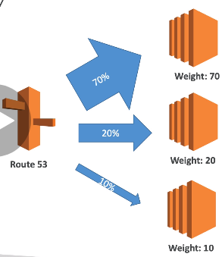
Weighted Routing Policy: control the % of the requests that go to specific endpoint. Helpful to test 1% of traffic on new app version for example. Helpful to split traffic between two regions. Can be associated with Health checks.

-Routing policy - latency: Redirect to the server that the least latency close to us. Super helpful when latency of users is a priority. Latency is evaluated in terms of user to designated AWS Region.
- Health checks: Have X health checks failed => unhealthy (3 is default). After X health checks passed => healthy (3 is default). Default interval checks: 30 seconds. (can set to 10s - higher cost). About 15 health checkers will check endpoint health. (HTTP, HTTPS, TCP health checks, no SSL). Possible to integrate with CloudWatch. Health checks can be linked to Route53 DNS Queries.

AWS S3

- Web app uploading LARGE files (4 GB) on S3 each 30min. User Multipart upload to minimize time required (upload single object as a set of parts).
- I want to create an authentication using social identity provider to upload files on S3. Enable guest user access to certain sections of website. TO do this you have to create an Identity Pool in Cognito and enable access to unauthorized identities.
- Ensure that all objects in S3 bucket are encrypted at rest using server-side encryption with AWS KMW-Managed Keys (SSE-KMS). Add a bucket policy which denies any s3:PutObject action unless the request includes the “x-amz-server-side-encryption” header.
-AWS CLI shell script to list all objects on S3. Avoid timing out -> add PAGINATION (--page-size).
- S3 behind CloudFront storing static content. Only premium are authorized to access. Unauthorized access should be denied. User Lambda@Edge and Cognito to authenticate and authorize premium customer.
- Webapp hosted in custom VPC with multiple private subnets. Every EC2 will require access to S3. Create a VPC endpoint for S3.
-Encrypted all object uploaded in S3. Server side encryption SSE-S3 with AES-256. Use “x-amz-server-side-encryption” for not deny request.
- private S3 bucket stored application logs and the buckets contents are accessible to all members of developer IAM group.However, I want to make an object inside the bucket which should only be accessible to the members of admin IAM group. How to apply an S3 bucket policy to thus object using AWS CLI? There is no way to do it. On AWS CLI you can only apply bucket level policy, not on objects. Use S3 access control lists instead to manage permissions of S3 objects. “put-bucket-policy” --policy is for bucket level.
- hosting website on S3,, local on “http://tutorialdojo.s3-website-us-east-1.amazon.com”. User JS on the webpage that are stored in this bucket to be able to make authenticated GET and PUT requests. These requests are directed to the same bucket through thw website.s3.amazonaws.com s3 api endpoint. However, you noticed that your web browser blocks the HTTP requests originating from your website. ENABLE CORS config in the bucket.
- app sending thousand of log files to an S3 bucket everyday. Command request to retrieve list of objects using AWS CLI “aws s3 api list-objects” is timing out due to the high volume of data being fetched. User PAGINATION to solve this problem. Parameters to include: “--page-size” and “--maaz-items”
-app allows the user to easily make cartoon animation and store the generated media files to AWS. IAM role created with permissions to upload file to S3 and other AWS resources. Which API call should you use to allow the app to upload files to S3? AssumeRole. To assume a Role, an ap calls the AWS STS AssumeRole API operation and passes the ARN of the role to user. The operations create a new session with temporary credentials.
- app hosted on EC2 with assigned IAM Role to store data from both the development and prod S3 bucket. THe instance also has an AWS CLI installed to handler other ad hoc tasks. You assigned a new IAM role to the instance which has the permission to access the development bucket only. However, upon testing, the instance can still store files to the buckets. The cause is that the application is still using IAM Role that is configured in the AWS CLI.
-must have globally unique name.
-defined at region level.
-Objects(files) have a key. The key is the FULL path.
-max size is 5TB(object)
- if upload more than 5GB, must be in multi-part upload
- Versioning: You can version your files in S3. It is enabled at Bucket level. Same key overwrite will increment the version: 1,2,3. Any file that is not versioned prior to enabling versioning will have version”null”.
- Encryption:
SSE-S3 -> encrypts S3 objects using keys handled and managed by AWS. Object is encrypted server side. AWS-256 encryption type. Must set header “x-amz-server-side-encryption” :”AES256” when you send you data to amazon S3 to make it work (HTTP or HTTPS + header).
SSE-KMS -> leverage AWS Key Management Service(you can manage over time) to manage encryption keys. KMS advantages: user control + audit trail. Object encrypted server side. Must set header: “x-amz-server-side-encryption” :”aws:kms”(HTTP or HTTPS + header).
SSE-C -> when you want to manage your own encrpytions keys. server-side encryption using data keys fully managed by the customer outside of AWS. S3 does not store the encryption key you provide. (MUST BE HTTPS). Encryption key must provided in HTTP headers, for every HTTP request made. HTTPS only + Data key in Header.
Client side encryption. Client library such as Amazon S3 Encryption Client. Clients must encrypt data themselves before sending to S3. Clients must decrypt data themselves when retrieving from S3. Customer fully manages the keys and encryption cycle.
-Security:
User based: IAM policies - which API calls should be allowed for a specific user from IAM console.
Resource Based:
Bucket policies -> bucket rules from the S3 console - allows cross account;

-Bucket policies: JSON based policies, Resources: buckets and objects. Actions: Set of API to allow or deny. Effect: allow/deny. Principal: The accountor user to apply the policy to. Use S3 bucket for policy to: Grant public access to the bucket, Force objects to be encrypted at upload, Grant access to another accout (Cross account).
-Networking: Support VPC endpoints (for instances in VPC without internet)
- Logging and auditing: S3 access logs can be stored in other S3 bucket. API calls can be logged in AWS CloudTrail.
- User security: MFA (multi factor authentication). can be required in versioned buckets to delete objects. Signed URLs: URLs that are valid only for a limited time.
-S3 can host static websites and have them accessible on the internet. The website URL is <bucket-name>.s3-website-<AWS-region>.amazonaws.com
- if you get 403, make sure bucket policy allows public reads.
-Consistency Model. Read after write consistency for PUTS of new objects. As soon as an object is written, we can retrieve it ex: (PUT 200 -> GET 200). This is true, except if we did a GET before to see if the object existed ex: 9GET 404 -> PUT 200 -> GET 404) eventually consistent. Eventual consistency for DELETES and PUTS of existing objects. If we read an object adter updating, we might get the older version ex: (PUT 200 -> PUT 200 -> GET 200 might be the older). If we delete an object, we might still be able to retrieve it for a short time ex: (DELETE 200 -> GET 200)
-Performance: have random key name to optimise performance. Use random ids. Never use dates as prefix keys. dont need to randomize.
-Use multipart loads for large objects (>= 100MB) Parallelize PUTs for greater throughput. decrease time to retry in case a part fails. Must use multi-part if object is greater than 5GB. Use Cloudfront to cache S3 objects around the world. S3 Trasnfer Acceleration (uses edge location) - jsut need to change the endpoint you write to. If you are using SSE-KMS encryption, you may be limited to your AWS limits for KMS usage(100s - 1000s downloads / uploads per second) if gets throttling, change KMS limits.

AWS SAM

- Set up a new serverless architecture composed of Lambda, API Gateway, DynamoDB, locally build, test and debug serverless app. Use SAM.
- Use to deploy serverless app. Serverless app can include one or more nested apps. To define nested app use AWS::Serverless::Application.
- all config in YAML code.
- generate complex CloudFormation from simples SAM YAML file.
- Transform represents that it is a SAM template-file.
- add S3ReadPolicy to insert in your serverless model template to give buckets access to for read access.
- Transform Header it’s SAM template. “Transform”: “AWS::Serverless-2016-10-31”. Write code AWS::Serverless::Function/API/SimpleTable

AWS Secret Manager:

- It replaces hard coded credentials.
- Improve ISMS - Information Security Management System
- Create a Secret Manager to enable Automatic Rotation of Database creation. (DB credentials encrypted and be automatically rotated).

AWS STS

-app allows the user to easily make cartoon animation and store the generated media files to AWS. IAM role created with permissions to upload file to S3 and other AWS resources. Which API call should you use to allow the app to upload files to S3? AssumeRole. To assume a Role, an ap calls the AWS STS AssumeRole API operation and passes the ARN of the role to user. The operations create a new session with temporary credentials.

AWS System Manager Parameter Store

- Lambda and API Gateway using proxy integration. Api caching enabled in API Gateway with TTL value of 300 secs. Client want to fetch latest data and invalidate cache. Send request with “cache-control: max-age=0” on header.

AWS Security Group

- Fundamental of network security in AWS. They control how traffic is allowed into or out EC2. Inbound all denied by default and outbound allowed everything by default. It is like a firewall on EC2 instances. Regulate access ports, authorise IP ranges, control inbound and outbound.

-Can be attached to multiple instances. Locked down to a region / VPC . It is good to maintain a separate security group for SSH. Application not accessible , probably security group issue.

- Security group can reference IP address, CIDR block, Security group.

AWS VPC

- Webapp hosted in custom VPC with multiple private subnets. Every EC2 will require access to S3. Create a VPC endpoint for S3. Inside VPC are EC2, EBS, ELB. S3 is outside of VPC.

AWS X-Ray

-App running elastic beanstalk. 200 requests per second. Results are stored on DynamoDB. For trouble shooting purposes, you were assigns to enable X-ray and sample a total of 160 requests per second. You should also ensure that you sample a percentage of matching requests after the reservoir is exhausted. How should you configure the sampling rules in X-ray to meet the above requirements? Set the reservoir size to 150 and the fixed rate to 20%. To ensure efficient and tracing and provide a representative sample of the requests that your application server, the x-ray SDK applies a sampling algorithm to determine which requests get traced. By default, the x-ray SDK records the first request each second, and five percent of any additional requests. Reservoir size is the target number of traces to record BEFORE applying the fixed rate. The reservoir applies across all services cumulatively, so you cant use it directly.

- How to filter with app results in X-ray console? Add custom attributes as annotation in your segment document.

-An app uses a RESTful API hosted in AWS, which uses Amazon API Gateway, Lambda and Dynamo. There has been a production issue in your app and you want to trace and analyze the use request as they go through you amazon API GW. X-ray is the best solution to troubleshoot it. You can use AWS X-Ray to trace and analyze user requests as they travel through your Amazon API Gateway APIs to the underlying services. X-Ray gives you an end-to-end view of an entire request, so you can analyze latencies in your APIs and their backend services.

-new IT policy requires you to trace all calls that your node app sends to external HTTP web APIs as well as SQL DB queries API hosted on ElasticBeanstalk, in order to properly trace calls via x-ray. Eanble x-ray daemon by including x-ray daemon config file in the ebextension directory of your source code.

- Lambda base app of several functions. Once triggered, various down streams resources like dynamoDB and S3 or API calls will be made. Requirement to trace event source that invoke all lambda functions and trace downsteam, number of requests and execution requests. X-ray can be used. X-ray collect data about requests, filter, gain insights into data to identify issues and opportunities to optimize.

-app using x-ray SDK to colelct all data about requests that an app servers. Requirement to create custom debug tool which will enable then to view full traces of their app without using x-ray console. Use “GetTraceSummaries” API to get the list of trace IDs of the app and then retrieve the list of traces using BatchGetTraces API

-website on ASG and EC2 instances with ALB in front to distribute incoming traffic. X-ray has been installed to call instances to allow debugging and troubleshooting using x-ray. From which source will x-ray fetch the client ip? From x-forwarded-for header of the request.

-ECS cluster running x-raythat enables to easily debug and troubleshoot app. Trace data is still not detected as expected. Provide more granular timing info and more details abou downstream calls to variou AWS resources. USE SUBSEGMENTS.

-record calls taht your app moakes to call AWS servies resources. Developed a custom code that will send the segment documents directly to x-ray by sugin “PutTraceSegments” api. What should include in your segment doc? SUBSEGMENTS.

-App hosted in on-demand EC2 instances. Which are valid considerations in x-ray? Set the “namespace” subsegment field to “aws” for AWS SDK calls and “remote” to other downstream calls. Set “metadata” object with any additional custom data that you want to store in the segment.

-Docker application on ECS has been intermittent unavailable issues and times out. Instrument the app to detect where high atencies are occurring and to determine the services and paths impacting app perform. First, configure the port mappings and network mode settings in your task definition file to allow traffic on UDP port 2000. Second, create a Docker image that runs x-ray daemn, upload it to a docker image repo, and deploy it to your ECS. The x-ray daemon is a software app that listens for traffic on UDP port 2000. gathers raw data and rellays it to X-ray API.

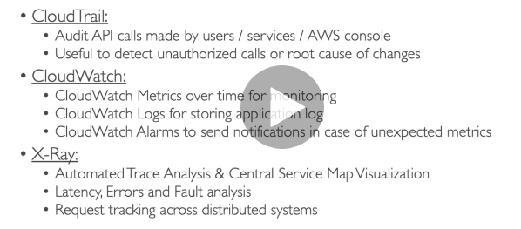
-X-ray instrumentation in your code: Measure product’s performance, diagnoses errors, and write trace info. To instrument your app , use X-RAY SDK. Only config changes. You can customize how x-ray works in your code.
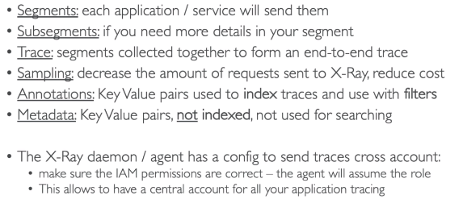

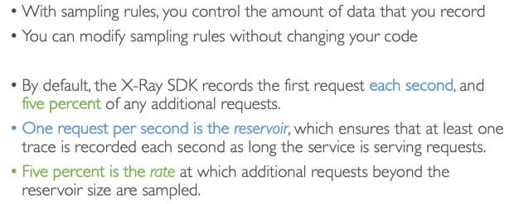
READ SIDE

